**FINAL REPORT**

**STATIC GRADIENT SURVEY**

Well: {{well_name}}

Field: {{field}}

Date: {{date}}

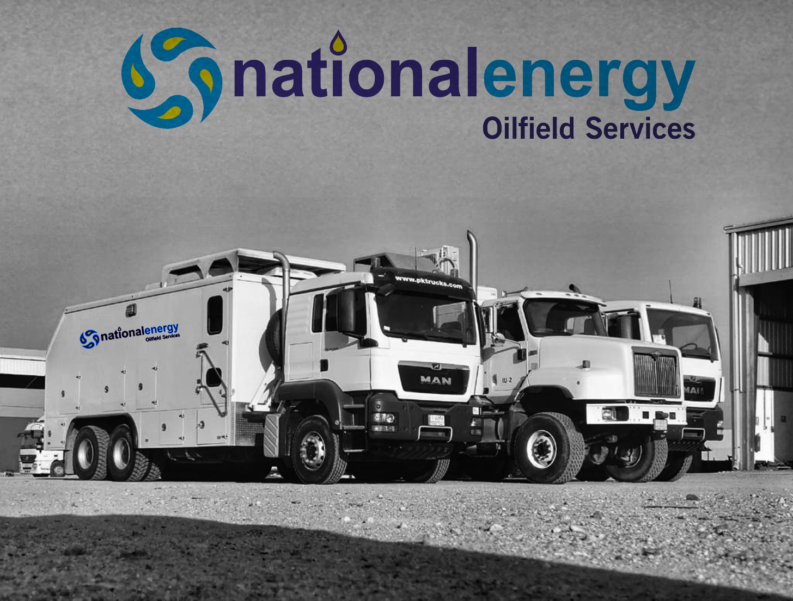

Table of Contents

SURVEY OBJECTIVES 3

BASIC WELL INFORMATION 4

SEQUENCE OF EVENTS 5

STATIC GRADIENT SURVEY RESULTS TABLE 5

STATIC GRADIENT SURVEY RESULT PLOTS 6

OVERALL DOWNHOLE MEMORY GAUGE PLOT 7

DOWN HOLE MEMORY GAUGES OVERALL COMPARISON 8

WELL COMPLETION DIAGRAM 9

WELLHEAD PICTURE­ 10

SLICKLINE MEMORY GAUGES STRING DIAGRAM 11

PCE SCHEMATIC 12

CALIBRATION TOP GAUGE D8701 13

CALIBRATION BOTTOM GAUGE D8700 14

# SURVEY OBJECTIVES

A Pressure Survey was carried out on {{date}} in well {{well_name}} of {{field}} field to perform {{type}} to evaluate the bottom hole pressure and temperature

# BASIC WELL INFORMATION

**GENERAL INFORMATION**

Company : TotalEnegies Ratawi Hub

Field : {{field}}

Well : {{well_name}}

DGS/CPS :

Test : {{type}}

Rig : RIGLESS

Country/City : IRAQ- BASRA

Depth Reference : GL (Ground Level)

Unit System : Field System

**OPERATION DETAILS:**

Date of test : {{date}}

Co. Representative : Coordinator

NEOS Representative : {{spv}}

**WELL DATA:**

States before test : Producer oil

Well type : {{welltype}}

Fluid type : {{fluid}}

Completion type : {{packer}}

Well status : Producer

Min restriction : {{min-res}}

Casing size : 9 5/8 in, 47 lb/ft, L-80

Tubing size : {{tubing}}

Liner size : 7”, 2.9#, L-80

Test interval : {{interval}}

# SEQUENCE OF EVENTS

|  |  |  |  |
| --- | --- | --- | --- |
| **Start** | **End** | **Total** | **Operation Description** |
| 06:00 | 07:00 | 01:00 | NEOS slickline crew left from the base to **RT-50.** |
| 07:00 | 09:30 | 02:30 | Got PTW. |
| 09:30 | 09:40 | 00:10 | Gas test was done (O2=20.9, Flammables =0% of LEL,H2S=0 PPM) Permit was signed off to PA. |
| 09:40 | 10:00 | 00:20 | Review JSA and held tool box meeting with slickline crew Job Risk Assessment discussion JRA. |
| 10:00 | 10:30 | 00:30 | Perform DROPs check list, offload equipment from transport truck and Scaffolding. |
| 10:30 | 10:45 | 00:15 | Pressure test against Aux valves,WHP 200 psi. **test OK** |
| 10:45 | 11:45 | 01:00 | Started R/U slickline equipment. |
| 11:45 | 12:00 | 00:15 | Remove wireline valve from frame and connect hydraulic hoses.  1. Function test wireline valve rams with hydraulic supply (close 10 sec, open 9 sec). 2. Hydraulic accumulator testing:  a. Accumulator pre-charge pressure: 1500psi  b. Accumulator pressurized to 3000 psi  c. Function testing each rams with accumulator (close 7 sec, open 7 sec, close 8 sec, open 7 sec).  d. Residual accumulator pressure: 2300 psi.  e. Bleed off hydraulic and accumulator pressure. |
| 12:00 | 12:30 | 00:30 | Pressure test Hose & Low torque Valve & PCE up to 250 psi /5min and 2700 psi /10 min **test Ok**. |
| 12:30 | 15:00 | 02:30 | Opened Swab RIH with **GC 2.8"** tagged HUD@ **3307** mGL inform **TEEPERH SPDT** and POOH**.** |
| 15:00 | 15:15 | 00:15 | Slickline tools at surface, Bleed off LUB & Prepare for next run. |
| 15:15 | 15:30 | 00:15 | Pressure testing for Quick test sub 2700 psi /10 min. |
| 15:30 | 17:15 | 01:45 | Opened Swab valve RIH with **TEL 3 1/2"** & **2.8" GC** located EOT @ **3084.7** mGL inform **TEEPERH SPDT** and POOH. |
| 17:15 | 17:30 | 00:15 | Slickline tools at surface, Bleed off LUB & Prepare for next run. |
| 17:30 | 18:17 | 00:47 | RIH two memory pressure /Temperature gauges **Top** SN: D8701, **Bottom** SN: D8700 and Stop at measuring depth **3303** mGL for 20 min. Night shift crew arrive at location and handover with day shift. |
| 18:17 | 21:07 | 02:50 | POOH gauges with **10** stations **10** min each **(3293, 3283, 3273, 3092, 2990,1990,1490, 990, 490, 0)** mGL as per Client instruction. |
| 21:07 | 21:15 | 00:08 | Slickline tools at surface, Bleed off LUB, disconnect memory gauges and download the data, inform **TEEPERH SPDT**  and start R/D. |
| 21:15 | 22:30 | 01:15 | Finished rig down and housekeeping . |
| 22:30 | 22:45 | 00:15 | Pressure test wellhead flange with 250 psi for 5 minutes and 2700 psi for 10 minutes, **test Ok** . |
| 22:45 | 23:59 | 01:14 | Close PTW and waiting Day shift. |

# STATIC GRADIENT SURVEY RESULTS TABLE

**Bottom Gauge D-8700**

# STATIC GRADIENT SURVEY RESULT PLOTS

**Bottom gauge D-8700**

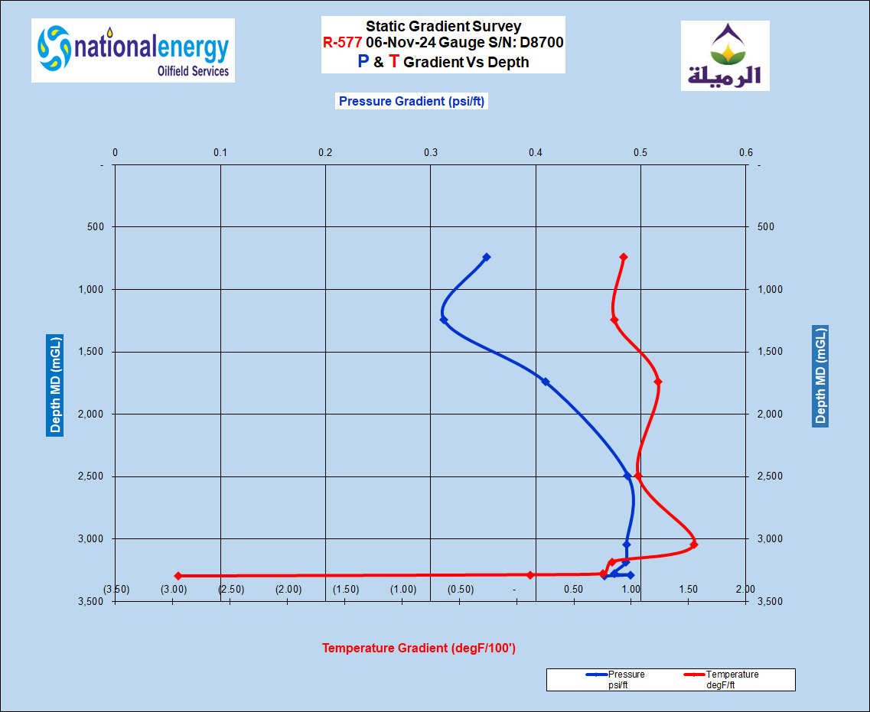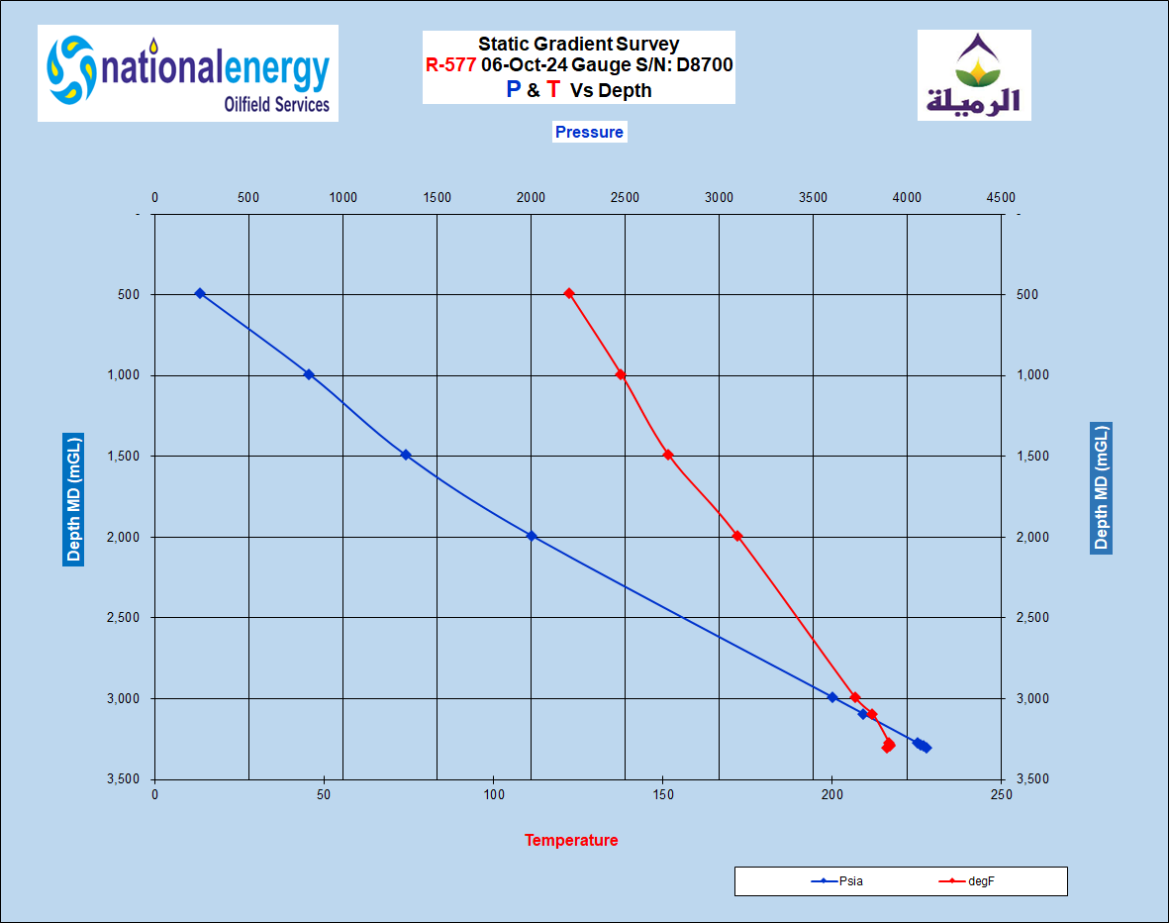

# OVERALL DOWNHOLE MEMORY GAUGE PLOT

**Bottom gauge D-8700**

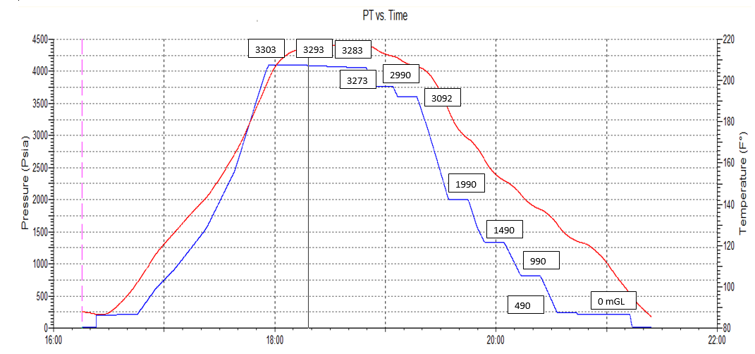

# DOWN HOLE MEMORY GAUGES OVERALL COMPARISON

**Bottom D8700, Top D8701**

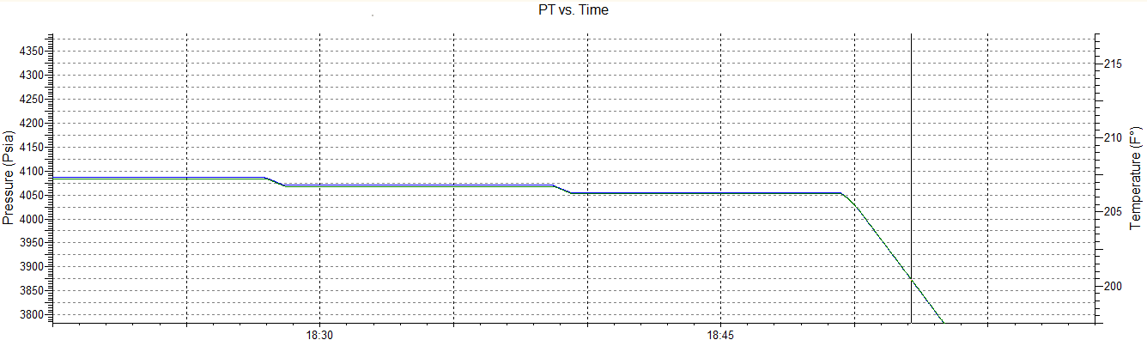

# WELL COMPLETION DIAGRAM

# WELLHEAD PICTURE­

# SLICKLINE MEMORY GAUGES STRING DIAGRAM

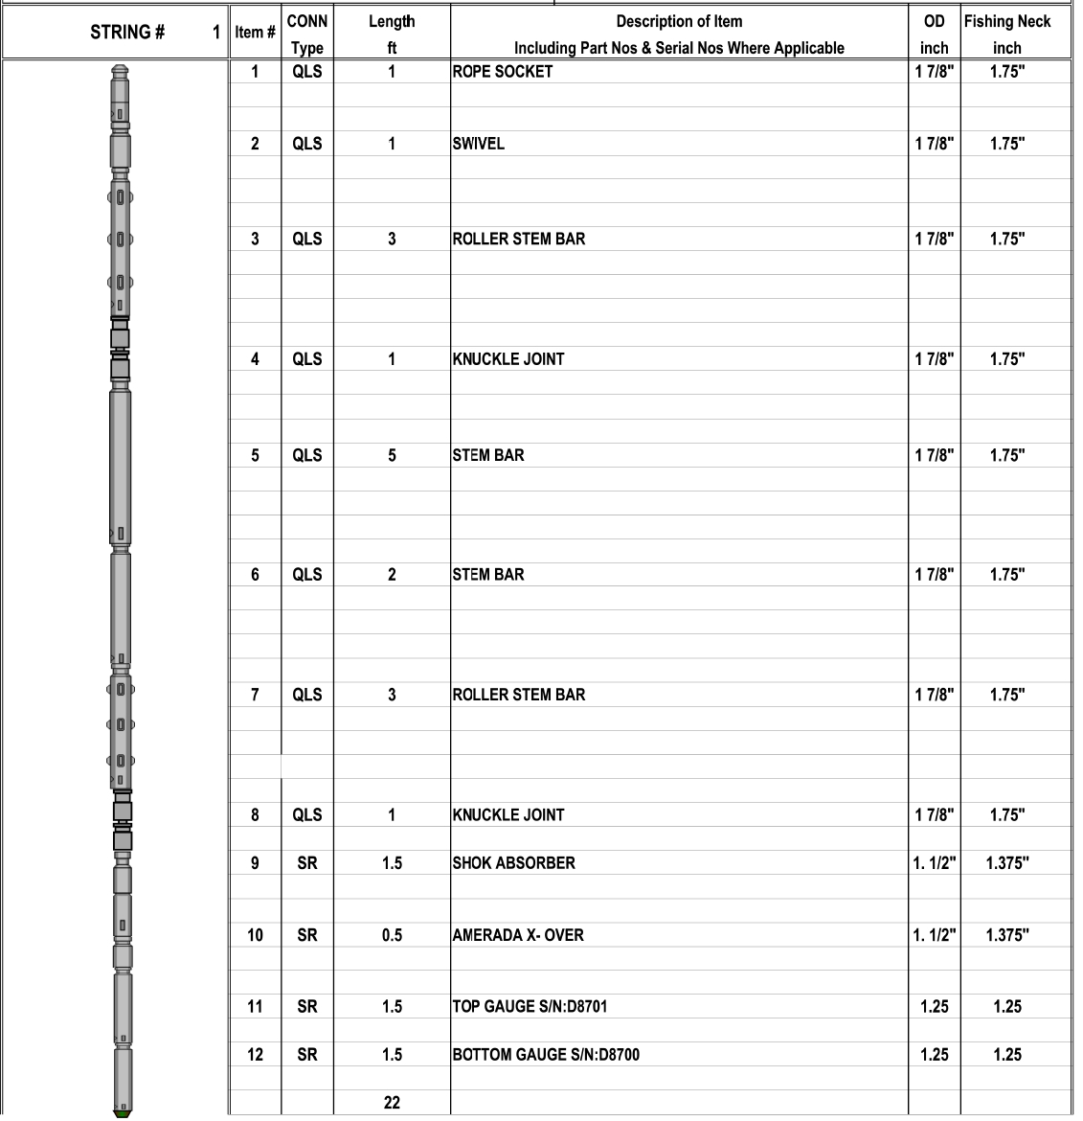

# PCE SCHEMATIC

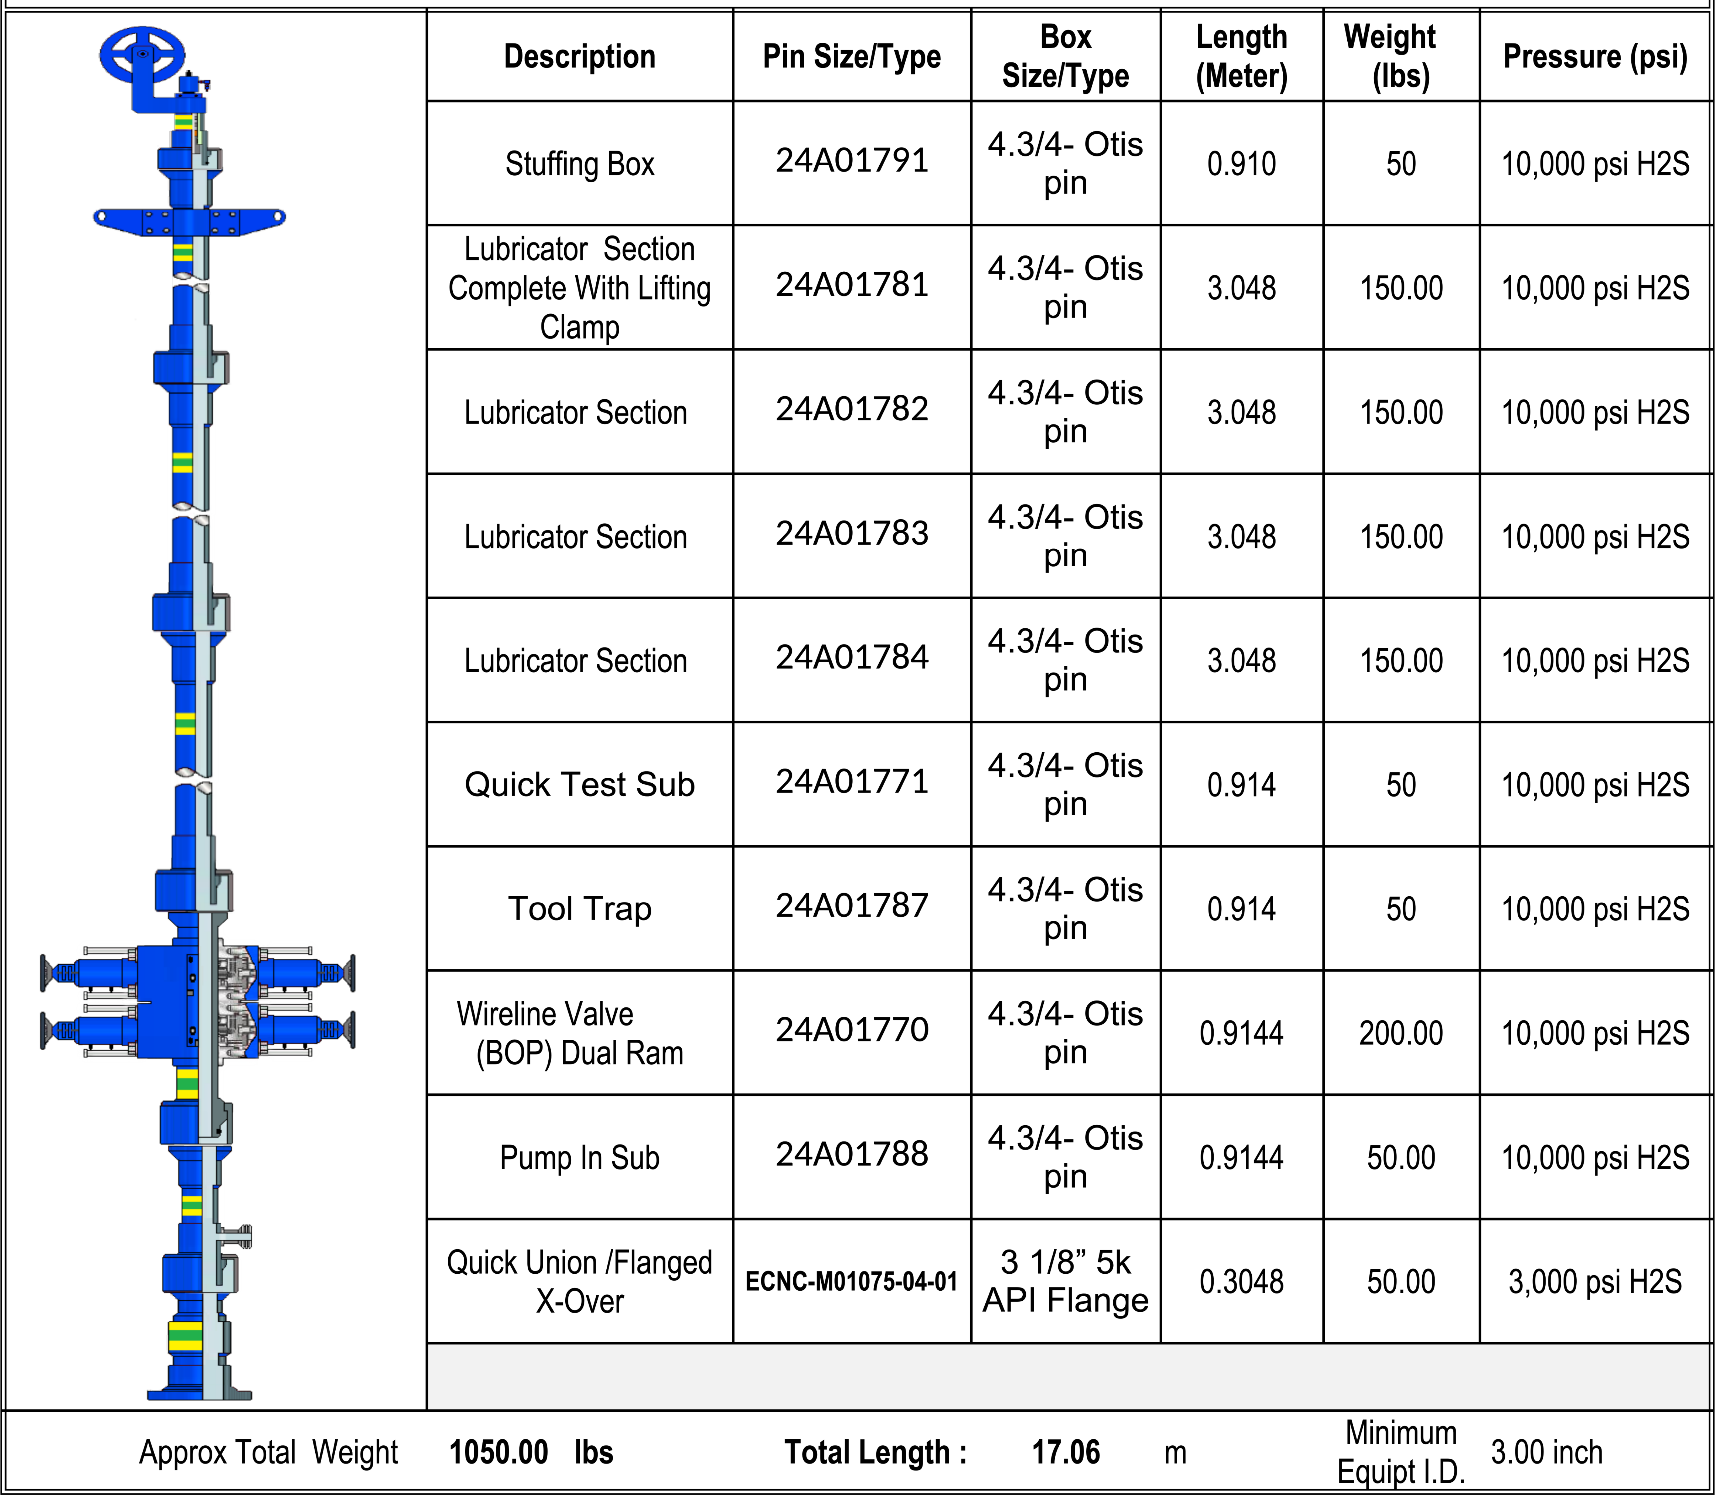

Example only

# CALIBRATION TOP GAUGE D8701

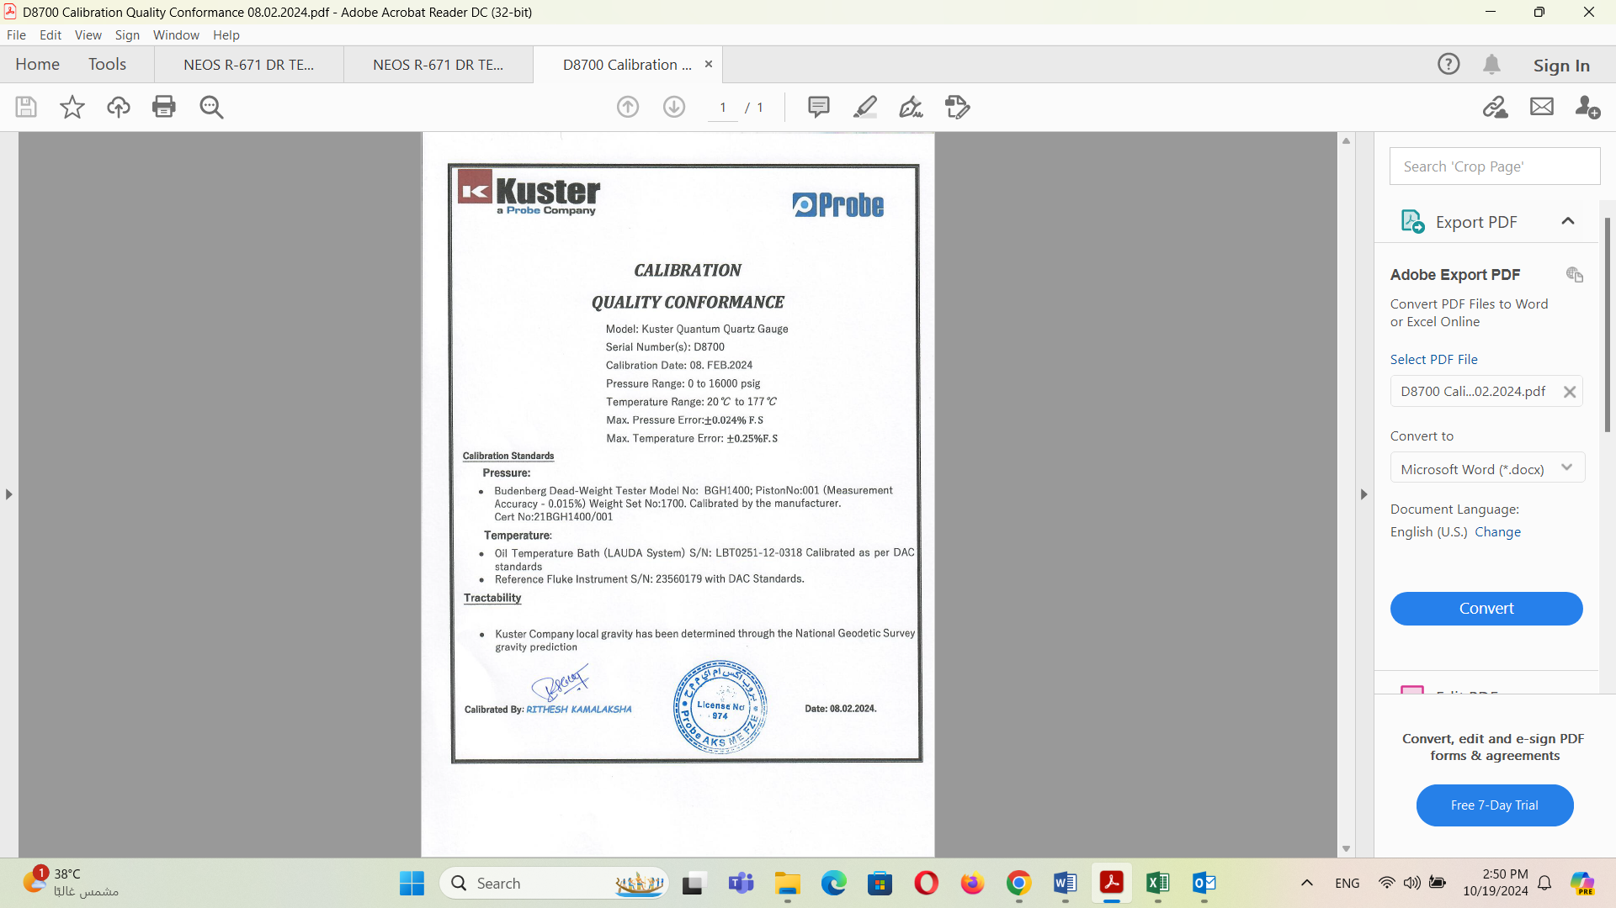

# CALIBRATION BOTTOM GAUGE D8700

